**CHAPTER 1**

**INTRODUCTION**

* 1. **Introduction**

In today's fast-paced world, managing tasks efficiently and staying on top of deadlines is essential for both personal productivity and professional success. Traditional methods of task management, such as paper-based lists or basic digital reminders, often lack smart functionalities, which can make it difficult to keep track of tasks and important events. To address these challenges, our project, **"Task Guardian: A Smart Reminder System for Cognitive Support,"** integrates intelligent algorithms and cognitive support to provide a personalized, smart task management experience.

The primary goal of this project is to create an advanced task reminder system that not only reminds users of their upcoming tasks but also offers cognitive support in managing those tasks. By leveraging smart notifications, prioritization algorithms, and intuitive interfaces, Task Guardian ensures that users are reminded of their important tasks at the right time, with the flexibility to adapt reminders based on user preferences and contextual information.

Our solution uses a robust technology stack to build a seamless user experience. The frontend is designed with HTML, CSS, and JavaScript, providing a modern and responsive interface for managing tasks. The backend is powered by Python and Flask, allowing for dynamic task creation, user authentication, and integration with an intelligent reminder system. The system’s data storage is handled by PostgreSQL database.ensuring that user data and tasks are stored securely and can be accessed efficiently.

One of the key features of Task Guardian is its cognitive support, which leverages intelligent algorithms to prioritize tasks based on deadlines, urgency, and user preferences. This feature helps users focus on the most important tasks first, reducing stress and improving productivity. Additionally, the system sends smart reminders that adapt to the user's habits and patterns, ensuring that notifications are both timely and relevant.

The task management feature of the system allows users to create, edit, and delete tasks, each with a title, description, due date, and priority level. Furthermore, users can set reminders and receive real-time notifications on their mobile or desktop devices. The system also provides a dashboard for tracking completed tasks and viewing upcoming deadlines.

Task Guardian also integrates a multi-layered authentication system with OAuth login options (Google/GitHub) and traditional email/password methods, ensuring secure access to user accounts. Additionally, users can recover their passwords through a token-based system for enhanced security.

The graphical user interface (GUI) of the system is designed to be simple yet powerful, enabling users to easily navigate between tasks, set reminders, and track their progress. The interface is responsive and optimized for both mobile and desktop users.

Overall, our project aims to revolutionize how individuals manage their tasks by providing a smart, user-centric, and cognitive support system. By integrating intelligent reminders, personalized prioritization, and a sleek interface, Task Guardian serves as an invaluable tool for anyone looking to improve task management and productivity.

* 1. **Existing System**

In many productivity and task management settings, traditional methods for managing tasks and setting reminders are still predominantly used. These methods often rely on manual lists, paper-based planners, or basic digital reminder applications, which can be time-consuming and prone to human error. Users typically have to spend extensive periods organizing their tasks manually—an inefficient process that can result in missed deadlines and forgotten tasks. Furthermore, traditional approaches often lack intelligent prioritization and dynamic reminders, leading to inconsistent task management and missed opportunities.

One common traditional method involves using paper-based to-do lists, where users write down tasks and their respective deadlines. This approach is highly inefficient, especially for users with a large number of tasks, as it requires significant time and effort to manually organize and update tasks. Additionally, paper-based lists are prone to human errors, such as forgetting to add tasks or failing to check off completed ones.

Another prevalent method involves using basic digital calendars or reminder apps. While these methods offer convenience and can help set alarms or notifications, they often lack advanced features such as task prioritization, cognitive support, or personalized notifications. Users are limited to simple reminders, without an intelligent system that adapts to their preferences and provides real-time feedback based on task urgency or relevance. As a result, traditional task reminder systems may not always meet the needs of users who require more advanced assistance in managing complex task lists and deadlines.

* 1. **Objective**
* **Develop a smart task reminder system with cognitive support.**
  + Replace traditional task management methods with an intelligent, automated solution.
  + Improve efficiency and productivity by offering cognitive support in prioritizing tasks
* **Enhance accuracy and reliability of task reminders.** 
  + Utilize advanced algorithms for task prioritization based on urgency and deadlines.
  + Implement robust reminder mechanisms for consistent and timely notifications.
* **Improve user experience**
  + Design a user-friendly web interface using HTML, CSS, and JavaScript.
  + Provide real-time notifications and updates for task reminders and deadlines.
* **Ensure data integrity and efficient management**
  + Maintain accurate task records in a PostgreSQL database.
  + Generate and display detailed reports for each task, including completion status and reminders.
* **Support large-scale deployment**
  + Develop a scalable solution suitable for both individual users and organizational use.
  + Ensure robustness and efficiency in diverse operational environments.
* **Provide flexibility in task management.**
  + Offer multiple methods for creating and updating tasks, including manual input and cognitive task suggestions.
  + Allow easy management of task settings, such as priority levels and deadlines.
* **Facilitate easy integration and maintenance**
  + Use widely adopted technologies and libraries such as Flask, Python, and PostgreSQL.
  + Provide clear documentation and support for setup and usage.
  1. **Scope of Work**

The project aims to develop an efficient and secure task reminder system that leverages cognitive support and intelligent algorithms to enhance user productivity. Task Guardian aims to automate task management processes, providing personalized reminders based on cognitive prioritization and task urgency.

* **Task Data Management** 
  + Allows users to create, update, and manage tasks.
  + Stores task data, including deadlines, descriptions, and priority levels, securely in a PostgreSQL database.
* **Task Reminder & Prioritization**
  + **Task Management:** Provides intelligent algorithms to prioritize tasks based on urgency and deadlines.
  + **Smart Reminders:** Sends personalized, timely reminders to users, adjusting based on their task completion habits and preferences.
* **Result Management**
  + Stores task reminder history and results securely in the database.
  + Provides features for data retrieval and filtering task.
* **Real-Time Notifications & Security**
  + Sends real-time notifications to users for upcoming tasks and reminders.
  + Implements security measures to ensure data integrity and prevent unauthorized access.
* **Graphical User Interface (GUI)**
  + Built using HTML, CSS, and JavaScript to provide seamless navigation and a responsive design.
  + Includes features for task management, reminder settings, and viewing task history.
* **Technology Stack**
  + **Frontend Programming Language:** HTML, CSS, JavaScript
  + **Backend Programming Language:** Python (Flask)
  + **Libraries & Frameworks:** Flask, jQuery, and other relevant libraries.
  + **Database:** PostgreSQL (local)
* **Project Development Plan**
  + Research and requirement gathering.
  + System design and database structuring.
  + Development of task management and reminder algorithms.
  + GUI development and integration with backend.
  + Testing, debugging, and final deployment.
* **Expected Deliverables**
  + A fully functional task reminder system with cognitive support for intelligent prioritization.
  + User documentation and an installation guide.
  + A secure and scalable system for individual or organizational use.
  1. **Operating Environment**

The project, **"Task Guardian: A Smart Reminder System for Cognitive Support,"** is developed in a Windows environment using Python for the backend and HTML, CSS,and JavaScript for the frontend. The backend is structured with Flask for API development, integrated with libraries and modules to manage user sessions, reminders, notifications, and OAuth authentication. The system uses a PostgreSQL database for storing user data, tasks, schedules, and system logs. HTTP requests between the frontend and Flask API facilitate seamless task management, notification updates, and real-time interactions. The web interface ensures a user-friendly experience for organizing and managing personal or professional tasks with intelligent support.

#### **1. Hardware Requirements**

To ensure smooth operation of the Task Guardian system, the following minimum hardware specifications are recommended:

1. **Processor**: Intel Core i3 or equivalent (minimum), Intel Core i5 or equivalent (recommended).
2. **RAM**: 4 GB (minimum), 8 GB (recommended) for smooth multitasking and API interactions.
3. **Storage**: At least 1 GB of free disk space for storing application files, user data, and system logs.
4. **Internet:** Required for real-time reminders, notifications, and API integrations (e.g., Google/GitHub OAuth.
5. **Display**: A monitor with a resolution of 1280x720 or higher to support a clean and responsive user interface.

#### **2. Software Requirements**

1. **Operating System**: Windows 10 or later (64-bit).
2. **Programming Language**: Python 3.8 or later (backend), JavaScript/HTML/CSS (frontend).
3. **Libraries & Tools**: Flask, psycopg2 (for PostgreSQL integration), smtplib (for email), requests, JWT (for authentication), and other related dependencies.
4. **IDE/Editor**: Visual Studio Code, PyCharm, or any suitable IDE for Python and frontend web development.
5. **Database**: PostgreSQL (local or cloud-hosted) for reliable and relational data management.
6. **Package Managers**: pip (for Python packages), npm (if using any JS utilities or build tools).

#### **3. Environment Scalability**

The operating environment of Task Guardian is designed to be scalable and adaptable to a growing user base and extended features with the following considerations:

1. **Hardware Scalability**: The application can be deployed on dedicated servers or cloud platforms with multi-core processors and extended RAM to handle concurrent user sessions and notification services.
2. **Software Scalability**: The backend and frontend can be containerized using Docker and managed using orchestration tools like Kubernetes for horizontal scaling. Cloud deployment on platforms like AWS, Azure, or Google Cloud enables high availability and load balancing.
3. **Database Scalability**: While the current setup uses a local PostgreSQL instance, it can be migrated to a cloud-managed solution like Amazon RDS or Azure Database forPostgreSQL to support larger datasets, improved query performance, and higher reliability.

**1.5.1. Software Specification**

1. **Programming Language**: JavaScript, Python 3.10 or later
   * JavaScript is used for building the frontend interface using HTML, CSS, and JavaScript.
   * Python is used for implementing backend logic, API services, session management, and reminder scheduling.
2. **Libraries and Dependencies**:
   * **Flask:** To create RESTful APIs that connect the frontend with the backend logic.
   * **psycopg2 / SQLAlchemy**: For interacting with the PostgreSQL database.
   * **Flask-Mail:** For sending email notifications and password recovery tokens.
   * **Flask-Login / Flask-SQLAlchemy:** For user authentication and session management.
   * **JWT / OAuthlib**: For implementing secure login with Google and GitHub.
3. **Database**: PostgreSQL (Local)
   * Used for storing user credentials, task data, reminders, notification logs, and activity history.
4. **Operating System**: Windows 10 or later (64-bit)
   * The project is developed and tested in a Windows environment.
5. **IDE/Editor**: Visual Studio Code
   * Used for writing and debugging both frontend and backend code efficiently.
6. **Browser**: Any modern web browser (e.g., Chrome, Firefox)
   * For testing the web application, managing tasks, and viewing reminder alerts.
7. **Additional Tools**:
   * **pip**: Python package manager for installing required libraries.

**1.5.2. Hardware Specification**

1. **Processor**:
   * Minimum: Intel Core i3 or equivalent
   * Recommended: Intel Core i5 or equivalent for smoother task scheduling, user interaction, and backend processing.
2. **RAM**:
   * Minimum: 4 GB
   * Recommended: 8 GB or higher for efficient management of multiple users, background reminders, and server-side processing.
3. **Storage**:
   * Minimum: 500 MB of free disk space for storing user data, task logs, and application files.
   * Recommended: 512 GB or higher for scalability and long-term storage of task records, user sessions, and configuration backups.
4. **Graphics**:
   * Minimum: Integrated GPU for handling standard browser-based UI rendering.
   * Recommended: Dedicated GPU (e.g., NVIDIA GeForce GTX series) is optional and only needed if extending features with AI or real-time analytics in the future.
5. **Display**:
   * Minimum: A monitor with a resolution of 1280x720 for basic interaction with the dashboard.
   * Recommended: Full HD (1920x1080) or higher for optimal usability and better layout rendering of the task interface.
6. **Libraries/Tools:**
   * Flask: For backend development and API routing.
   * PostgreSQL**:** For storing structured task data securely and efficiently.
   * SMTP & OAuth (Google/GitHub): For authentication, notification, and password recovery features.
   * JavaScript, HTML, CSS**:** For building a responsive frontend interface.
7. **Peripherals**:
   * Keyboard and mouse for input and navigation within the task dashboard.
   * Optional: External storage devices for backing up PostgreSQL databases and logs.
   1. **Description of Technology Used**
8. **Python**: Python is the core programming language used in this project due to its readability, vast ecosystem, and effectiveness in handling backend development, logic building, and integration with external services.
9. **JavaScript:** JavaScript is used for developing the frontend of the application. It enables dynamic content rendering and interaction between the user interface and backend logic.
10. **HTML & CSS:** These are the foundational technologies used to structure and style the web interface. They help in creating a clean, responsive layout for managing tasks and reminders.
11. **Flask API:** Flask is a lightweight and flexible Python web framework used to build RESTful APIs and manage backend logic. It handles user authentication, task processing, session control, and communication with the PostgreSQL database.
12. **PostgreSQL:** PostgreSQL is an advanced open-source relational database system used to manage structured data related to users, tasks, reminders, and system settings. It ensures robust data integrity, scalability, and security.
13. **OAuth (Google/GitHub):** OAuth is implemented to support third-party login systems, enabling secure user authentication through Google and GitHub in addition to traditional email/password login.
14. **SMTP:** The system uses SMTP for sending notification emails, password recovery links, and other user-related communications.
15. **JavaScript Libraries (jQuery):** jQuery is used to simplify DOM manipulation, event handling, and AJAX operations for smoother frontend interactions.
16. **Visual Studio Code:** Visual Studio Code is the IDE used for development. It offers powerful extensions, debugging tools, and version control support for managing both frontend and backend code efficiently.
17. **JSON**: JSON format is used for data exchange between the frontend and backend, particularly for handling API requests and responses smoothly.

# CHAPTER 2

# LITERATURE REVIEW

The **"Task Guardian: A Smart Reminder System for Cognitive Support"** is built upon advancements in web development, intelligent systems, and backend technologies. The following literature and technologies provide the foundation for this project:

1. **Cognitive Task Management Algorithms:** Cognitive support systems have been studied extensively in the context of productivity tools. These systems use behavioral data and priority-based logic to help users focus on the most important tasks. Literature suggests that cognitive reminders enhance time management, reduce mental load, and support habit formation.
2. **Web Development Frameworks:** The frontend is developed using HTML, CSS, andJavaScript, offering a responsive and interactive user interface for task management. Studies in user interface design stress the importance of clarity, minimalism, and ease of navigation, especially for productivity tools intended for broad user bases.
3. **Flask for API Development:** Flask, a lightweight Python web framework, serves as the core of the backend. It is widely adopted for building RESTful APIs due to its simplicity, scalability, and extensive community support. Research shows Flask is effective for rapid prototyping and integrating backend logic with user interfaces.
4. **Task Scheduling and Notification Systems:** Intelligent reminder systems are a focus of research in human-computer interaction. Automated scheduling, recurring tasks, and contextual reminders based on user activity are proven to improve productivity. Implementing real-time alerts through browser notifications or emails is aligned with current trends in digital task management.
5. **PostgreSQL for Data Storage:** The system uses PostgreSQL, a powerful open-source relational database, to manage user data, task records, and authentication details. Research highlights PostgreSQL’s strength in data consistency, integrity, and scalability for high-performance applications.
6. **Authentication and Security Models:** Secure authentication systems, including OAuth (Google/GitHub) and traditional email/password logins, are essential for protecting user data. Token-based recovery mechanisms and session handling further align with best practices in secure application design.
7. **User Experience (UX) and Interface Design:** A well-designed graphical user interface(GUI) significantly impacts usability. The interface of Task Guardian is designed for clarity, accessibility, and adaptability across devices. Studies confirm that intuitive UX design boosts user engagement and long-term retention of productivity tools.

This project integrates these technologies and methodologies to create a reliable and intelligent task reminder system. By leveraging existing research and modern tools, Task Guardian provides a practical, secure, and user-focused solution for effective personal task management and productivity enhancement.

# CHAPTER 3

# PROPOSED SYSTEM / METHODOLOGY

**3.1. User Requirement Specification**

The **"Task Guardian: A Smart Reminder System for Cognitive Support"** is designed to meet the following user requirements:

1. **Task Creation and Management:** The system should allow users to create, update, and delete tasks through a user-friendly web interface, including task details such as title, description, due date, and priority.
2. **Cognitive Support for Prioritization:** The system should utilize intelligent logic or rule-based algorithms to prioritize tasks based on urgency, deadlines, and user-defined importance.
3. **Flask API for Backend Processing:** The system should include a Flask-based REST API to handle user requests for task operations such as creation, updates, deletions, and reminders.
4. **Reminder Scheduling and Notification:** The system should manage and schedule task reminders efficiently, ensuring real-time notifications are sent to users via supported channels (e.g., browser alerts or email).
5. **Task Analytics and Progress Tracking:** The system should support analysis features like progress tracking, completion history, and pending task overview for better productivity management.
6. **Database Management:** The system should store user data, task records, and reminder configurations securely using PostgreSQL for efficient and scalable data management.
7. **Error Handling:** The system should provide user-friendly error messages for issues such as invalid task input, failed database operations, or scheduling conflicts.

**3.2. Creation of a Dataset**

The dataset for the Task Guardian system is developed by collecting and organizing user task information, which is essential for enabling cognitive prioritization, intelligent reminders, and personalized productivity insights. This structured dataset forms the foundation for smart decision-making in task management. Below are the steps involved in dataset creation:

**1. Task Entry Collection:**

* During data preparation, task data is collected through the user interface or API endpoints.
* Each task is tagged with attributes such as title, description, deadline, priority level, completion status, and associated user ID.
* Data is validated and sanitized before being saved to ensure consistency and avoid duplication.

**2. Task Data Storage:**

* Task entries are stored in a PostgreSQL database using structured tables.
* Tables are normalized to store user details, tasks, reminder settings, and login credentials.
* A typical task entry includes:
* Task ID
* Title
* Description
* Due Date
* Priority
* Status
* User ID (foreign key)

**3. CSV File for Metadata:**

* A CSV export feature is provided for administrative analysis and backup purposes.
* The exported CSV includes columns such as:  
  TASK_ID, TITLE, DESCRIPTION, DUE_DATE, PRIORITY, STATUS, USER_ID
* Example:  
  001, "Submit Project Report", "Finalize and upload report", 2025-04-20, High, Pending, 101

**4. Data Augmentation (Cognitive Enhancement):**

* Intelligent enhancement is applied using algorithms that analyze user behavior (e.g., task completion trends, time delays).
* This helps predict task urgency and suggest prioritization changes.
* Techniques include frequency analysis, urgency scoring, and time-based reminders.

**5. Directory Structure:**

The dataset is organized in both logical and physical formats:

* **PostgreSQL Database Tables:**
  + users: Stores user login and profile info.
* tasks: Stores task records.
* reminders: Stores notification settings and timestamps.
* auth_tokens: Used for secure login/session handling.

This structured and scalable dataset approach ensures efficient task management, real-time reminders, and reliable cognitive support functionalities across the Task Guardian system.

**3.3. Pre-processing**

Pre-processing is a crucial step in the **"Task Guardian: A Smart Reminder System for Cognitive Support"** to ensure that the input data (user task entries and form submissions) is clean, consistent, and ready for further processing and analysis. Below is a theoretical explanation of the pre-processing steps implemented in the system:

**1. Task Data Pre-processing:**

* **Input Standardization:** All task inputs (e.g., title, description, due date, priority) are standardized to ensure a consistent format across all user entries.
* **Text Normalization:** Inputs are cleaned to remove special characters, HTML tags, and potential SQL injections to ensure application security.
* **Data Sanitization:** Techniques such as rotation, flipping, and zooming are applied to increase the diversity of training data and reduce overfitting.
* **Duplicate Check:**  The system checks for similar or duplicate task entries to reduce redundancy and improve task management efficiency.

**2. Date and Time Handling:**

* **Validation:** Date and time inputs are validated against acceptable formats to avoid processing errors and ensure proper scheduling.
* **Timezone Conversion:** If users are in different timezones, time values are converted to a consistent timezone to maintain accuracy in reminders.
* **Deadline Categorization:** Tasks are categorized based on their urgency—overdue, due soon, or completed using backend logic.

**3. Data Validation:**

* **Input Format Check:** All user inputs are checked to ensure correct data types (e.g., strings for task name, datetime for deadlines).
* **Field Requirement Enforcement:** Required fields (e.g., task title and due date) are enforced before submission to prevent incomplete records.
* **Length Limiting:** Inputs exceeding a certain length (e.g., task titles beyond 100 characters) are flagged or truncated to ensure database compatibility.

**4. Database Organization:**

* **Schema Validation**: Submitted data is matched against the PostgreSQL schema for consistency and relational integrity.
* **Table Structure Handling:** Tasks are categorized and stored in appropriate PostgreSQL tables for active tasks, completed tasks, and archived data.
* **User-wise Grouping:** Task data is grouped by user ID for isolation and privacy of user-specific data.

**5. Data Decoding (if applicable):**

* **Token Decoding:** In case of OAuth login (Google/GitHub), authorization tokens are decoded and verified for valid user sessions.
* **JSON Parsing:** Data sent from the frontend is parsed and decoded from JSON format before being stored in the database.

**6. Backend Input Preparation:**

* **Dictionary to Object Mapping:** ask data is mapped into Python objects or dictionaries, then serialized for further processing.
* **Status Flags Assignment:** Boolean flags such as isCompleted, isImportant, or reminderSent are initialized and updated during processing.
* **Timestamp Conversion:** Date fields are converted to timestamps where needed for comparison in scheduling and analytics operations.

**3.4. Feature Extraction**

Feature extraction in the **"Task Guardian: A Smart Reminder System for Cognitive Support"** focuses on identifying key task-related parameters and behavioral patterns of users to enable intelligent task prioritization and timely reminders.

1. **Task Data Acquisition:** The system accepts task input from users via the web interface. Each task includes a title, description, due date, priority level, and optional reminders.
2. **Task Data Preprocessing:** Submitted task data is preprocessed to remove inconsistencies and ensure uniformity. Preprocessing steps include trimming whitespace, validating input formats (e.g., date and time), and checking for duplicate or redundant entries.
3. **Contextual Data Conversion:** To simplify cognitive analysis, input data is structured into a standard format. Due dates and time-based reminders are converted into timestamp formats for scheduling and comparison.
4. **Task Segmentation:** Tasks are segmented based on urgency and importance using rule-based logic. This allows the system to focus on the most relevant tasks and avoid cluttered reminders.
5. **Feature Vector Creation:** Key features such as due time proximity, frequency of task type, and user-defined priority levels are used to form feature vectors. These are then passed to the task recommendation and prioritization engine.
6. **Dimensionality Reduction:** To ensure efficient scheduling, less significant features are filtered out. This step helps improve system response time while preserving the core attributes necessary for smart decision-making.

Feature extraction ensures that Task Guardian can effectively analyze and learn from task input and user behavior. This capability enables the system to deliver personalized, accurate, and timely reminders that improve productivity and task management efficiency.

**3.5 Sequence Diagram**

A sequence diagram is a type of UML diagram used to represent the interaction between different components or objects in a system over time. It visually depicts how and in what order messages are exchanged between participants to carry out a specific function or process. Each participant is shown with a lifeline a vertical dashed line representing the existence of the object over time and messages are represented as arrows going from one lifeline to another, indicating the direction and type of communication, such as synchronous or asynchronous calls. Sequence diagrams are particularly useful for modeling dynamic behavior in complex systems, including scenarios like user authentication, data retrieval via API calls, payment processing, or any multi-step system workflows. They offer a time-ordered view of how processes are initiated, how control flows through different parts of the system, and how responses are generated and sent back. By clearly showing the sequence of interactions, these diagrams help ensure that all system requirements are covered and that components are working together efficiently.

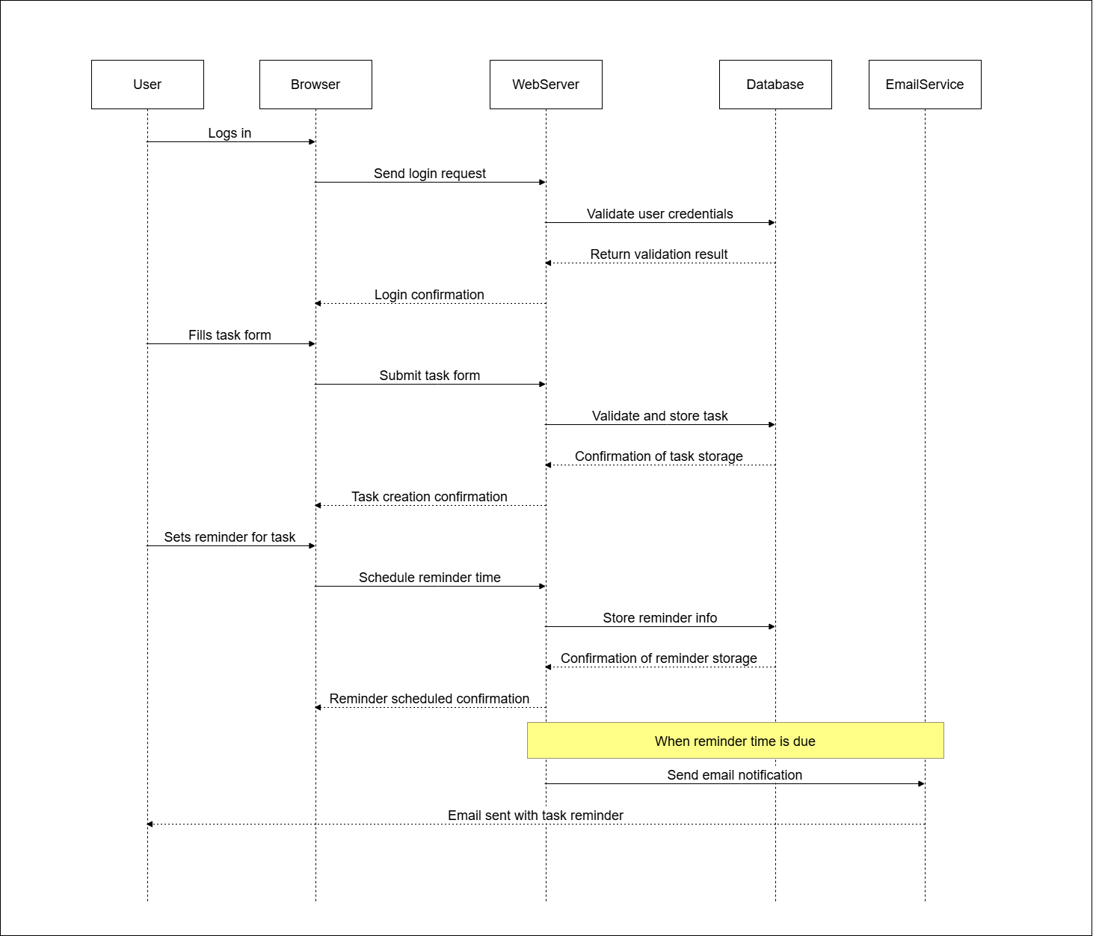

***Fig.1: Sequence Diagram***

The sequence diagram illustrates the workflow of the “Task Guardian: A Smart Reminder System with Cognitive Support.” The process begins with the user registering an account, during which their credentials are securely stored in the database and a confirmation is returned. After registration, the user logs in, prompting the system to validate their credentials through the database and grant access upon successful verification. Once logged in, the user can create a new task by providing details such as title, description, deadline, and priority. The system saves this task in the database and then communicates with the ReminderEngine to schedule smart reminders based on the task’s urgency and user preferences. At the scheduled time, the ReminderEngine triggers a notification and sends it to the user. The user may then update the task status to mark it as completed. This entire flow, from user registration and login to task creation, reminder generation, and task completion, is represented in the diagram to showcase the interactive and intelligent behavior of the system.

**3.6 DeploymentDiagram**

A deployment diagram is a type of UML diagram that shows the physical architecture of a system. It illustrates how software components (like applications, databases, APIs) are deployed on hardware nodes (like servers, cloud services, or user devices). It helps to understand where and how the system runs, showing the relationships between software and hardware. It's useful for visualizing things like frontend on a browser, backend on a server, and database on a local or cloud machine.

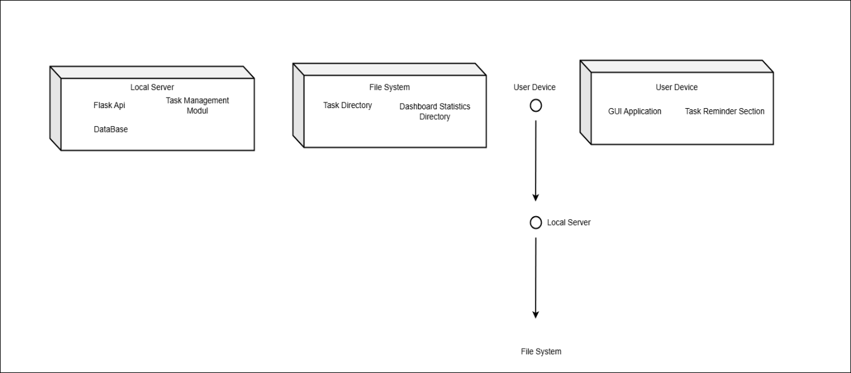

***Fig.2: Deployment Diagram***

The deployment diagram shows how the components of the “Task Guardian: A Smart Reminder System with Cognitive Support” are distributed across different physical nodes. The system consists of three main parts: the User Device, Application Server, and Database Server. On the User Device, a web-based interface allows users to interact with the system, perform actions such as registration, login, task creation, and reminder setup. These requests are sent to the Application Server, which hosts the Flask backend application that processes all the logic related to task management, user authentication, and reminder scheduling. The Application Server communicates with the PostgreSQL Database Server, which is responsible for securely storing user credentials, task details, and reminder configurations. The interaction involves the User Device sending requests to the server, which then processes the data and performs database operations accordingly.

**3.7 Component Diagram**

A component diagram is a type of UML diagram that shows the high-level structure of a system by depicting the various software components (such as classes, modules, services, or databases) and their relationships. It helps to visualize how different parts of the system are organized and how they interact with each other. Unlike other diagrams that focus on flow or timing, a component diagram emphasizes the modular structure and dependencies between components, making it easier to understand how the system's functionality is divided and how each part works together.

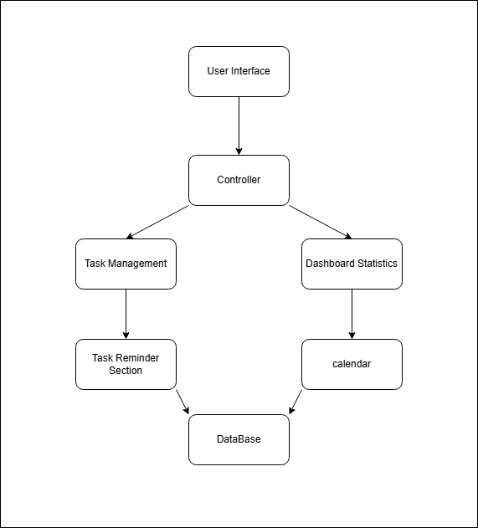

***Fig.3: Component Diagram***

This component diagram illustrates the core structure of the “Task Guardian: A Smart Reminder System with Cognitive Support” At the top, the User Interface represents the frontend (built with HTML, CSS, and JavaScript), where users interact with the system by creating, editing, and viewing tasks. Simultaneously, the controller communicates with the Database (PostgreSQL), which manages and stores user data, task details, and system preferences. This organized setup ensures a well-structured flow from user actions through backend processing and secure data management, allowing seamless interaction and real-time task support

**CHAPTER 4**

**RESULT AND IMPLEMENTATION**

**4.1 Methods / Techniques**

1. **Task Creation and Management Interface**: The frontend, built with HTML, CSS, and JavaScript, offers a clean and intuitive interface for users to create, update, and delete tasks. The form allows users to enter task titles, descriptions, due dates, priority levels, and toggle reminders. Users receive immediate visual feedback, enhancing the overall experience before submission.
2. **Task Data Handling and Preprocessing**: On the backend, form data submitted by the user is validated and structured. The system ensures required fields are completed and formats (like date/time) are correct. This preprocessing guarantees smooth integration with the database and prepares data for reminder scheduling and analysis.
3. **Cognitive Support** : A custom logic engine prioritizes tasks based on deadlines, urgency, and user-defined preferences. The system can categorize and suggest focus areas, offering cognitive support to improve productivity. The priority algorithm ensures that urgent tasks are highlighted and scheduled appropriately.
4. **Flask API Integration**: The **Flask backend** acts as a middleware between the frontend and PostgreSQL database. All user requests—such as task addition, retrieval, updates, or deletions—are routed through RESTful API endpoints that manage data securely and efficiently.
5. **PostgreSQL for Storage**: Task data, user details, reminder settings, and logs are stored in a PostgreSQL database. The database schema is optimized to manage relations between users, tasks, and notifications while supporting fast query execution and data integrity.
6. **Real-time Feedback and Notifications**: Once a task is added, users receive real-time feedback through the interface. Notifications for upcoming or overdue tasks are handled using time-based triggers or cron jobs, helping users stay on track with their responsibilities.
7. **System Architecture and Flow**: The system follows a modular, service-oriented architecture, with clear separation between frontend, backend, and database layers. HTTP requests from the frontend interact with the Flask API, which communicates with PostgreSQL to manage tasks and reminders. This modularity enables scalability and maintainability.
8. **Error Handling and Validation**: Comprehensive error-handling mechanisms ensure invalid inputs (e.g., missing data, wrong formats) are flagged on both frontend and backend. Exceptions are logged with helpful debug information, enabling efficient troubleshooting and robust system performance.
9. **Security Measures**: Input validation and API protection mechanisms help prevent injection attacks or unauthorized access. The system currently supports email/password authentication, with provisions to integrate OAuth (Google/GitHub) for secure user authentication in future deployments.
10. **User Interface Enhancements and Future Expansion**: The interface is designed with expandability in mind. Planned enhancements include task analytics charts, productivity tracking, and custom user dashboards. These features will help users visualize performance trends and gain deeper insights into their task management habits.

**4.2 Implementation**

1. **Task Creation and Overview Interface**: The frontend, built using HTML, CSS, and JavaScript, provides a clean and responsive interface for users to add new tasks. Users can input task titles, descriptions, due dates, and priority levels. The interface also provides an instant preview of upcoming tasks, ensuring a smooth and intuitive user experience.
2. **Task Data Processing**: On the backend, user-submitted task details are validated, structured, and stored efficiently. Input fields are checked for consistency, and all dates and priorities are standardized to maintain data integrity and allow smooth backend processing.
3. **Cognitive Support Logic**: The system incorporates a logic engine that applies cognitive principles to suggest task prioritization. Based on due dates, urgency, and task frequency, the system reorders or highlights tasks needing immediate attention. This smart support helps users stay organized and productive.
4. **Flask API Integration**: The backend is developed with Flask, acting as an API layer between the frontend and the PostgreSQL database. When users interact with the task manager, the Flask server handles requests such as adding, updating, deleting, or retrieving tasks. These operations occur in real time, maintaining a seamless experience.
5. **PostgreSQL for Storage**: Task data, including titles, descriptions, due dates, reminder settings, and user account information, is securely stored in a PostgreSQL database. This provides structured, relational data storage with scalability and security.
6. **Real-Time Reminders and Feedback**: After a task is created, the system sends real-time reminder notifications based on the user's chosen time. Notifications include task details and priority levels, helping users take timely action and avoid missing deadlines.
7. **System Architecture and Flow**: The system follows a modular architecture, with clear separation between frontend, backend, and database layers. ask requests are handled through HTTP calls to the Flask API, which communicates with the.
8. **Error Handling and Validation**: obust error-handling mechanisms are in place to validate inputs and catch server-side issues. Invalid or incomplete task inputs trigger user-friendly messages. Backend logging is implemented to help developers track and fix any anomalies efficiently.
9. **Security Measures**: The system includes form validation and route protection to prevent unauthorized or malicious inputs. User sessions and sensitive actions are protected. OAuth integration (Google and GitHub) adds secure user authentication options alongside traditional email/password login.
10. **Dashboard Visualization and Future Enhancements**: The user dashboard provides a visual overview of tasks categorized as pending, completed, or overdue. The design supports future enhancements such as productivity analytics, progress charts, and user-customizable themes for improved usability.

**Source code:**

**task.py :-**

from flask import Blueprint, request, jsonify

import psycopg2

from psycopg2.extras import RealDictCursor

from datetime import datetime

from tables import get_db_connection

from auth import token_required # Import the JWT decorator

task_blueprint = Blueprint("task", _name_)

@task_blueprint.route("/create", methods=["POST"])

@token_required

def create_task(current_user_id):

data = request.get_json()

name = data.get("name")

list_name = data.get("list_name")

notes = data.get("notes")

priority = data.get("priority", False)

date = data.get("date")

time = data.get("time")

completed = data.get("completed", False)

repeat_frequency = data.get("repeat_frequency", "none")

repeat_interval = data.get("repeat_interval", 1)

end_repeat = data.get("end_repeat")

schedule_time = data.get("schedule_time")

if not name or not date:

return jsonify({"success": False, "message": "Task name and date are required"}), 400

try:

conn = get_db_connection()

cursor = conn.cursor()

cursor.execute("""

INSERT INTO tasks (

user_id, name, list_name, notes, priority, date, time, completed,

repeat_frequency, repeat_interval, end_repeat, schedule_time

) VALUES (%s, %s, %s, %s, %s, %s, %s, %s, %s, %s, %s, %s)

RETURNING id

""", (

current_user_id, name, list_name, notes, priority, date, time, completed,

repeat_frequency, repeat_interval, end_repeat, schedule_time

))

task_id = cursor.fetchone()[0]

conn.commit()

return jsonify({

"success": True,

"message": "Task created successfully",

"task_id": task_id

}), 201

except Exception as e:

conn.rollback()

return jsonify({"success": False, "message": str(e)}), 500

finally:

cursor.close()

conn.close()

@task_blueprint.route("/", methods=["GET"])

@token_required

def get_tasks(current_user_id):

date_filter = request.args.get("date")

try:

conn = get_db_connection()

cursor = conn.cursor(cursor_factory=RealDictCursor)

base_query = """

SELECT

id,

name,

list_name,

notes,

priority,

to_char(date, 'YYYY-MM-DD') as date,

to_char(time, 'HH24:MI') as time,

completed,

repeat_frequency,

repeat_interval,

to_char(end_repeat, 'YYYY-MM-DD') as end_repeat,

to_char(schedule_time, 'HH24:MI') as schedule_time

FROM tasks

WHERE user_id = %s

"""

if date_filter and date_filter.strip():

cursor.execute(f"{base_query} AND date = %s", (current_user_id, date_filter))

else:

cursor.execute(base_query, (current_user_id,))

tasks = cursor.fetchall()

return jsonify({

"success": True,

"message": "Tasks retrieved successfully",

"tasks": tasks

}), 200

except Exception as e:

return jsonify({"success": False, "message": str(e)}), 500

finally:

cursor.close()

conn.close()

@task_blueprint.route("/update/<int:task_id>", methods=["PUT"])

@token_required

def update_task(current_user_id, task_id):

data = request.get_json()

name = data.get("name")

list_name = data.get("list_name")

notes = data.get("notes")

priority = data.get("priority")

date = data.get("date")

time = data.get("time")

completed = data.get("completed")

try:

conn = get_db_connection()

cursor = conn.cursor()

cursor.execute("""

UPDATE tasks

SET name=%s, list_name=%s, notes=%s,

priority=%s, date=%s, time=%s, completed=%s

WHERE id=%s AND user_id=%s

""", (name, list_name, notes, priority, date, time, completed, task_id, current_user_id))

if cursor.rowcount == 0:

return jsonify({"success": False, "message": "Task not found or unauthorized"}), 404

conn.commit()

return jsonify({"success": True, "message": "Task updated successfully"}), 200

except Exception as e:

conn.rollback()

return jsonify({"success": False, "message": str(e)}), 500

finally:

cursor.close()

conn.close()

@task_blueprint.route("/delete/<int:task_id>", methods=["DELETE"])

@token_required

def delete_task(current_user_id, task_id):

try:

conn = get_db_connection()

cursor = conn.cursor()

cursor.execute("""

DELETE FROM tasks

WHERE id=%s AND user_id=%s

""", (task_id, current_user_id))

if cursor.rowcount == 0:

return jsonify({"success": False, "message": "Task not found or unauthorized"}), 404

conn.commit()

return jsonify({"success": True, "message": "Task deleted successfully"}), 200

except Exception as e:

conn.rollback()

return jsonify({"success": False, "message": str(e)}), 500

finally:

cursor.close()

conn.close()

**4.3 Entity Relationship Diagram**

An Entity Relationship Diagram (ERD) is a visual representation of different entities within a system and how they relate to each other. Entity relationship diagrams are used in software engineering during the planning stages of the software project. They help to identify different system elements and their relationships with each other.

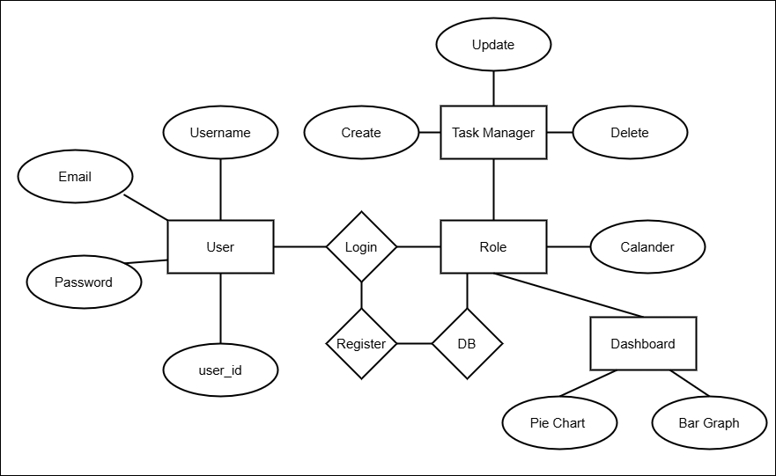

***Fig.4: Entity Relationship Diagram***

The above Entity-Relationship (ER) Diagram for Task Guardian: A Smart TReminderSystem with Cognitive Support illustrates the core structure and relationships among the primary data entities in the system. At the center is the User entity, which holds key attributes such as user_id, username, email, and password_hash, representing the essential information for user identification and authentication. Users are associated with the system through a Register relationship, which connects them to the Role entity. The Role entity defines different levels of access and permissions within the system, such as admin and standard users, ensuring proper authorization and security. The system’s main functionality revolves around the Task entity, which is linked to the User entity and contains attributes like task_id, title, description, due_date, priority_level, and status. This entity enables users to manage their tasks effectively, incorporating cognitive support for prioritization and tracking. To enhance usability, each task can be linked to a Reminder entity, which includes attributes such as reminder_id, reminder_time, notification_status, and delivery_method. This enables the system to provide smart, timely notifications and updates, ensuring that users stay on top of their tasks.

**4.4 UML Diagram**

A UML (Unified Modeling Language) diagram is a visual representation used to model the structure and behaviour of a system. It consists of various types of diagrams, such as class, object, use case, sequence, and activity diagrams, each serving a specific purpose in illustrating different aspects of the system. UML diagrams help in designing and understanding complex software systems by providing a standard way to visualize the system's architecture, relationships, and interactions.

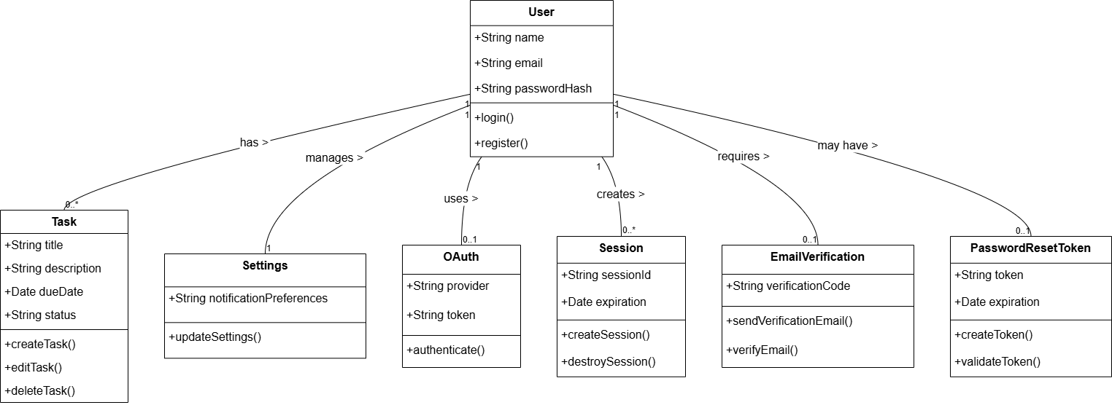

***Fig.5: UML Diagram***

The above UML class diagram illustrates the foundational structure and interactions of the main components within the Task Guardian System. Central to the system is the TaskGuardianSystem class, which orchestrates task and user management through core functionalities like addTask(), setReminder(), registerUser(), and loginUser(). This class works closely with the User class, which encapsulates user details such as username, email, and passwordHash, and provides methods like register() and login() to handle user authentication and registration. Data handling responsibilities are assigned to the Database class, which ensures persistent storage and validation of user and task data via methods including saveUser(), saveTask(), and validateUser(). The system also integrates the ReminderEngine class, which is responsible for managing reminders based on attributes such as reminderTime and priorityLevel, and includes methods like triggerReminder() and evaluatePriority() to intelligently notify users based on their schedules and task urgency. This class-based structure embodies key object-oriented design principles and showcases how each component contributes to the seamless functionality, smart scheduling, and secure operation of the Task Guardian System.

**4.5 Module Specification**

The "Task Guardian" system is divided into multiple functional modules, each responsible for specific tasks within the overall architecture. Below is the detailed specification of each module:

1. **Task Management and User Interface Module:** This module provides the frontend interface using HTML, CSS, and JavaScript. Users can create, update, and delete tasks. The UI is designed to be clean, responsive, and user-friendly, supporting task creation forms, real-time status updates, and a dynamic dashboard for tracking task progress.
2. **Task Processing and Prioritization Module:** This module handles internal task processing, including setting priorities, sorting tasks based on urgency, and managing due dates. It supports contextual decision-making for effective task ordering and cognitive support.
3. **Reminder Notification Module:** This module generates and manages smart reminders using task metadata. It calculates when to send alerts and ensures timely notifications are delivered to users through the frontend and system notifications.
4. **Flask API & Backend Logic Module:** Developed using Flask, this module connects the frontend to backend services. It processes task data, handles authentication, and manages interactions between the client interface and the database. JSON responses are used to communicate between the frontend and backend.
5. **Database and Storage Module:** This module handles data storage using PostgreSQL. It securely stores task details, user information, reminder configurations, and logs. The module also ensures efficient data retrieval and updates in response to user activity.
6. **Error Handling Module:** This module handles exceptions and runtime issues during task creation, update, deletion, or reminder scheduling. It ensures meaningful error messages are returned to the user and logs all errors for developers to diagnose and resolve problems quickly.
7. **Task Analysis and Reporting Module:** Though not exposed directly to users, this module analyzes completed and pending tasks, generating insights like task frequency, missed deadlines, and completion rates. These analytics help users understand productivity trends.
8. **Security and Access Control Module:** This module manages user authentication and authorization using OAuth integration (Google/GitHub) along with email/password login. It secures access to sensitive user data and task records, ensuring only authorized users can interact with their dashboard and task details.
9. **Visualization and Dashboard Module**: This module enables users to visually track their tasks via an interactive dashboard. It displays upcoming tasks, recent activity, completed tasks, and key performance indicators, offering an intuitive and informative interface.

**4.6 Data Flow Diagram**

A Data Flow Diagram (DFD) visually represents how data flows through the Task Guardian system, capturing the interaction between users, backend logic, and data storage in a structured and meaningful way. The process begins with the User accessing the system through a web-based interface developed using HTML, CSS, and JavaScript, ensuring a clean and responsive user experience. The initial interaction typically involves user registration or login, where credentials are submitted to the backend server built using Python Flask APIs. These credentials are validated against the PostgreSQL database, and upon successful verification, a session token is created and stored to maintain secure access throughout the user’s interaction with the system. After authentication, the user is directed to a dynamic dashboard interface, where they can perform various task-related operations such as adding new tasks, updating existing ones, deleting completed or irrelevant tasks, or viewing task summaries and full details. All task-related actions are handled by the backend logic and are immediately stored or updated in the PostgreSQL database. Simultaneously, a Task History Log maintains a record of all operations performed by the user for accountability and tracking purposes. The user can choose to view a Task Summary List, which presents an organized overview of all current tasks, offering deeper insight into individual task information such as due dates, status, and modification history. When such conditions are met, alerts or notifications are automatically triggered to ensure users are promptly informed.

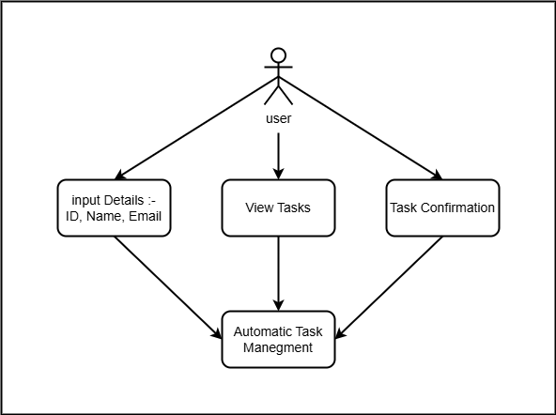

***Fig.6.: Level 0 Data Flow Diagram***

The above data flow diagram represents the comprehensive working of the Task Guardian system, designed to streamline task management with intelligent support features. The process initiates when the user registers or logs in using their credentials through the user interface. This information is authenticated against stored records in the user database, and upon successful verification, a session is created and maintained to ensure secure, personalized access throughout the interaction. Once logged in, the user can create and submit detailed task entries, including essential fields like task title, description, due date, priority level, and category. These inputs are transmitted to the task processing module, where the backend—powered by Flask (Python)—handles the logic for storing task data in a PostgreSQL database. Alongside storage, the system implements cognitive logic, which evaluates each task based on factors like urgency, importance, deadline proximity, and user-defined settings. This evaluation plays a vital role in automatically classifying tasks and scheduling them for optimized attention. The reminder engine, a key component of the system, uses this analysis to schedule and trigger reminders or notifications based on each task's characteristics and the user's preferences. These reminders are intelligently timed to provide proactive assistance, helping users stay on track without the need for constant manual checking. Notifications may appear via the dashboard or alert popups, ensuring they are noticeable and actionable.

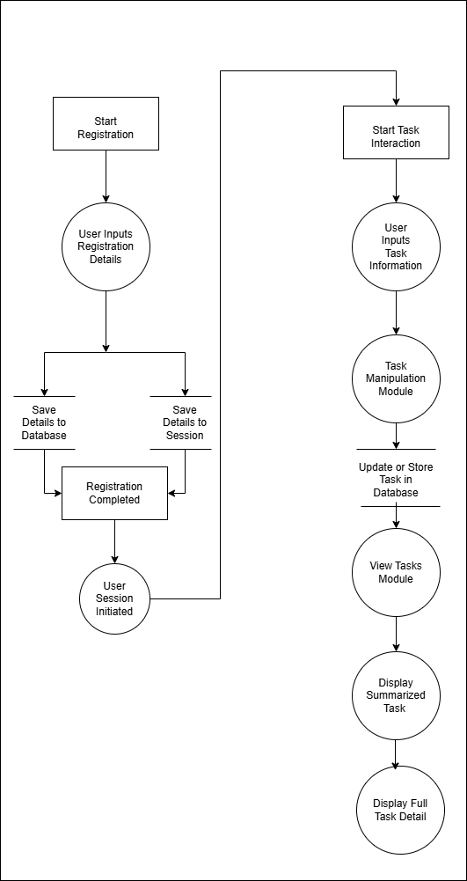

**Fig.6.1: Level 1 Data Flow Diagram**

The above Level 1 Data Flow Diagram provides a detailed breakdown of the system's internal processes and how data flows between them. The process begins when the user registers by inputting their details into the system. These details are saved in both the database and a session container to maintain continuity across sessions. After registration, the user interacts with the system by providing task-related information. This information is handled by the task manipulation module, which processes the data and sends it to the database for storage or updates. Once stored, the user can access the task information through the view tasks module, which fetches data from the database and presents a summarized record. For more comprehensive information, the system allows the user to display the task details in full. This level illustrates the interaction among five key processes: user registration, session handling, task manipulation, database storage, and task viewing, ensuring a streamlined, responsive, and user-centric workflow.

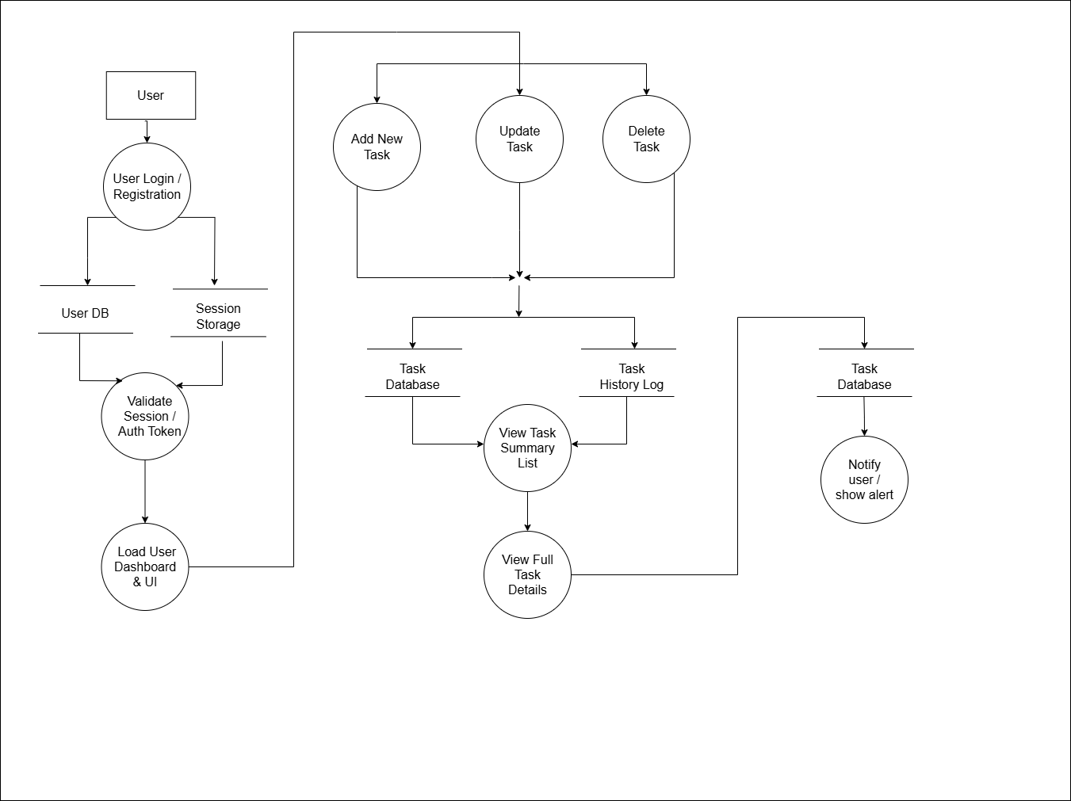

**Fig.6.2: Level 2 Data Flow Diagram**

The above Level 2 Data Flow Diagram provides a detailed view of the internal operations within the Task Guardian system. It begins with the user performing login or registration, which interacts with the User Database to verify or store user credentials and stores session-related data in Session Storage to maintain a secure and continuous user experience. The system then proceeds to validate the session or authentication token to ensure authorized access before granting entry to the main dashboard and user interface. Once authenticated, the user is presented with a clean and interactive interface, where they can add new tasks, update existing ones, or delete completed or unwanted tasks. These task operations are processed in real-time by the backend, developed using Flask (Python), and are simultaneously stored in the Task Database managed by PostgreSQL. Every action related to task manipulation is also logged into a Task History Log, which serves as an audit trail to track changes, identify user activity, and support potential future analytics. Additionally, the system is equipped with a notification mechanism that actively monitors the Task Database for important dates, such as due deadlines or overdue tasks, and generates alerts or reminders to keep the user informed and on track.

**4.7 User Interface Design**

The user interface (UI) of the "Task Guardian: A Smart Reminder System with Cognitive Support" is designed to be clean, intuitive, and responsive, offering users an efficient experience for managing tasks, receiving reminders, and interacting with cognitive features. The frontend is developed using HTML, CSS, and JavaScript, following standard web design practices for broad compatibility and optimal performance. Below is a breakdown of the UI design elements:

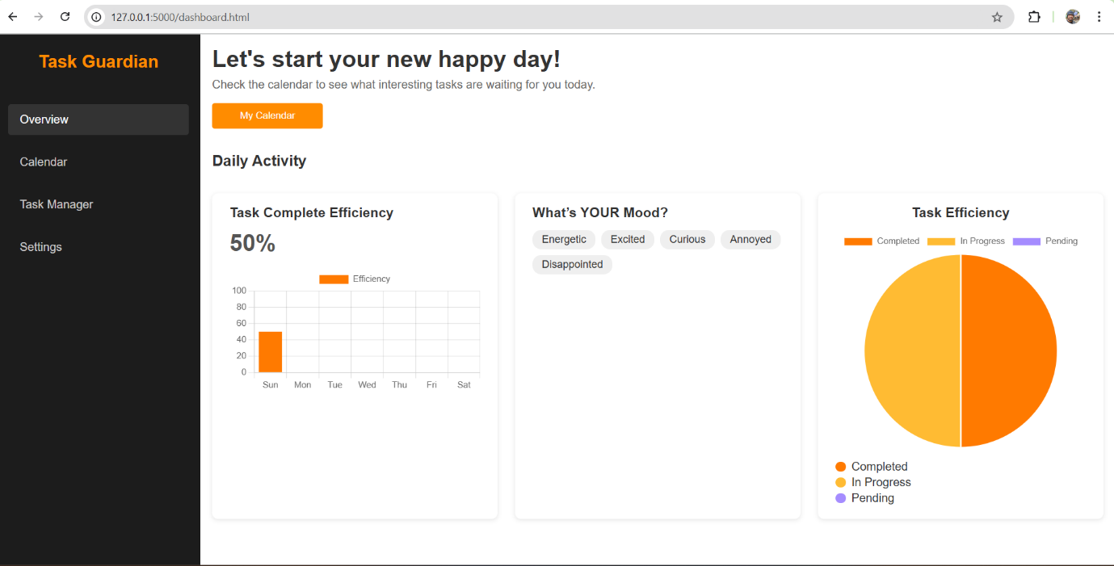**User Interface Page:**

**Fig 1: User Interface**

* **Main Interface:** The main dashboard serves as the core interaction hub for users. It includes a header, task input form, and sections for viewing active, completed, and upcoming tasks. The layout uses a simple and structured design with soft color themes to reduce visual clutter and enhance readability.
* **Title and Header:** The title “Task Guardian: A Smart Task Reminder System for Cognitive Support” is displayed prominently at the top, clearly communicating the purpose of the system to users upon login.
* **Layout Sections:**
* Task Creation Form: A form allowing users to input task title, description, due date, and priority level. It includes input validation and visually distinct input fields for usability.
* Task Lists (Active/Completed)**:** Users can view categorized task cards showing task details, due dates, and reminder statuses. Tasks are organized for easy navigation and status updates.
* **Input Fields:** Each form field (title, description, date, priority) is styled using custom CSS for a consistent look. Placeholder text and labels guide the user through the input process.
* **Buttons:**
* Add Task: Submits the task data to the backend for processing and storage in the PostgreSQL database.
* Clear From: Resets the input fields for new task entry.
* Edit/Delete: Allows updating or removing existing tasks from the list.
* **Reminder Feedback & Notification System:**
* Real-time reminders are displayed as alert boxes or toast notifications.
* Task cards visually update when a task is completed or approaching its deadline.
* A spinner animation or loader icon shows up during data loading or update operations.
* **Styling:** The interface is styled with standard CSS, applying modern design principles such as hover effects, smooth transitions, spacing consistency, and responsive layout adjustments. Custom styling is applied for buttons, cards, and forms to ensure accessibility and aesthetics).
* **Responsive Design:** The UI is fully responsive and adapts to various screen sizes (mobile, tablet, desktop), ensuring usability across devices.
* **Future Enhancements:**
* Authentication UI: To enable secure login via email/password and OAuth (Google/GitHub), with personalized dashboard views and user-specific task history.
* Multilingual Support: To serve a broader range of users by offering UI language preferences.

**4.8 Use Case Diagram**

A use case diagram is a visual representation of the interactions between users (actors) and a system, depicting the system's functional requirements. It illustrates various use cases, which are scenarios where the system performs tasks that provide value to the actors. The diagram helps in understanding the system's behaviour from the user's perspective and in identifying all possible ways the system will be used. This makes it an essential tool for communicating system requirements and ensuring all user interactions are considered in the design phase.

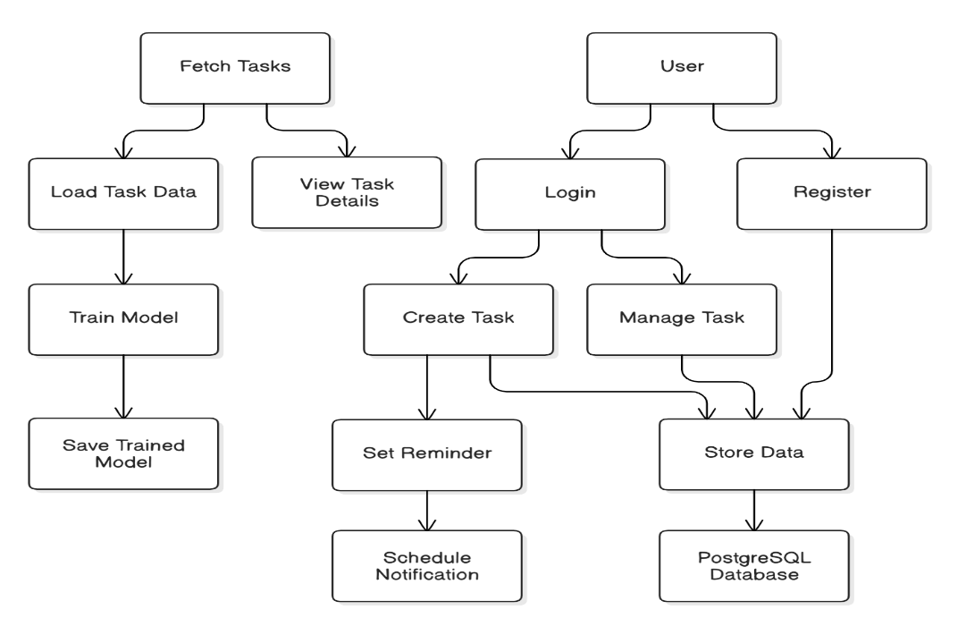

***Fig.7: Use case diagram***

The above use case diagram illustrates the core functionalities of the "Task Guardian: A Smart Reminder System for Cognitive Support" from the perspective of a user. The user can perform several key actions: register to create an account, log in to securely access the system, create and manage tasks by adding details such as title, description, due date, and priority, and set reminders for upcoming deadlines. Upon setting a reminder, the system intelligently schedules notifications based on user preferences and task urgency. Additionally, the system is responsible for storing all user and task data, ensuring secure data management and accessibility through the integrated PostgreSQL database.

* 1. **Output / Screenshot**
     1. 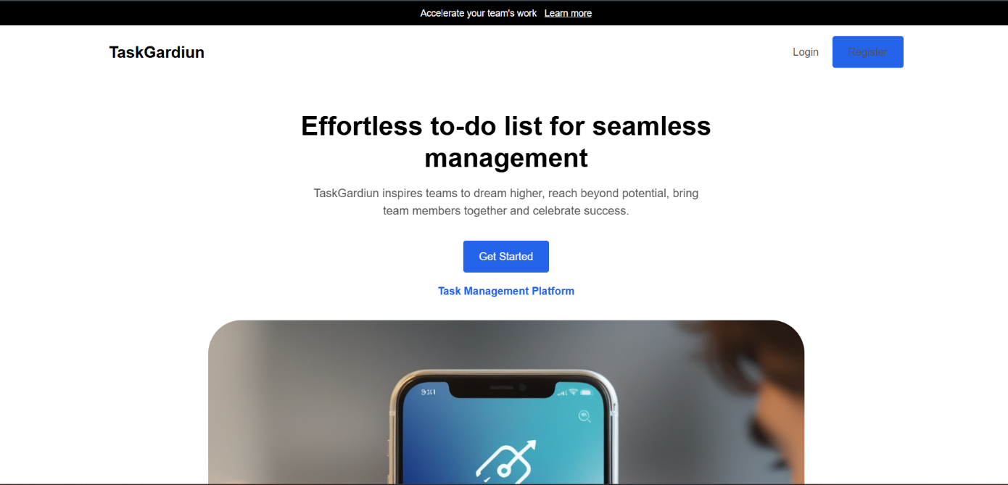**Landing Page**
     2. **Home Page**
     3. 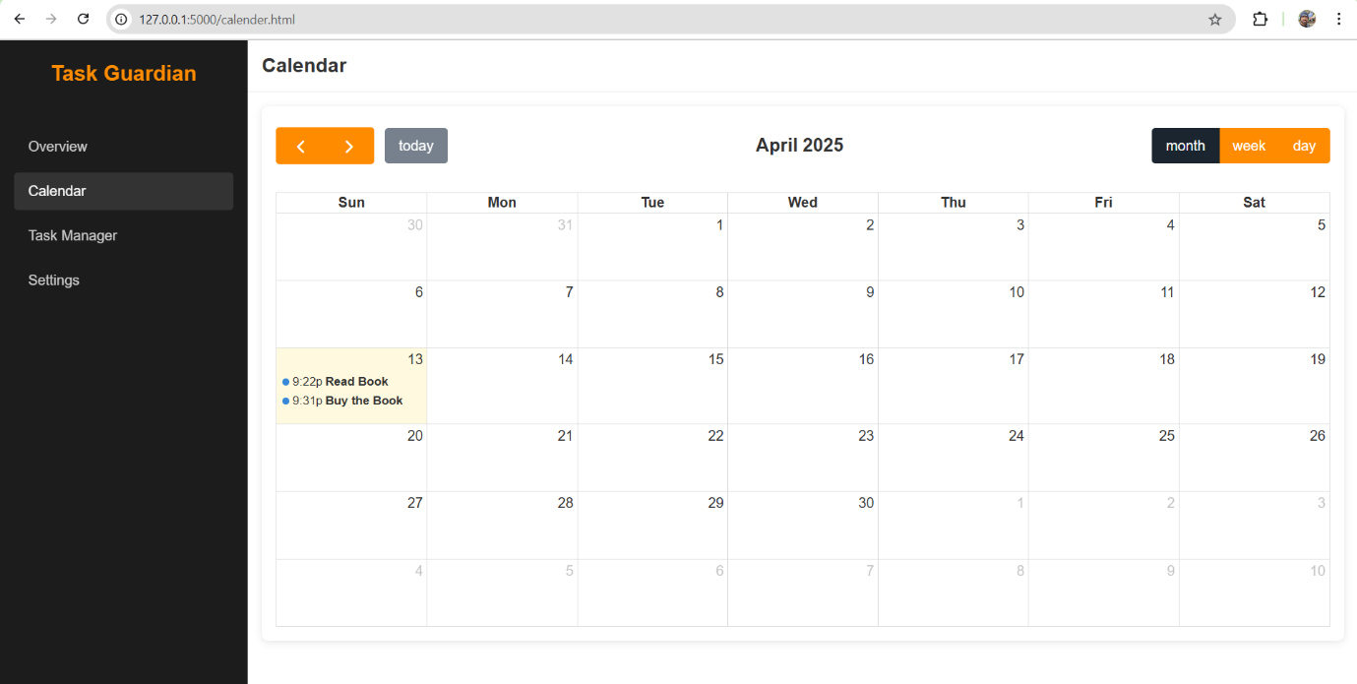**Calendar Page**
     4. 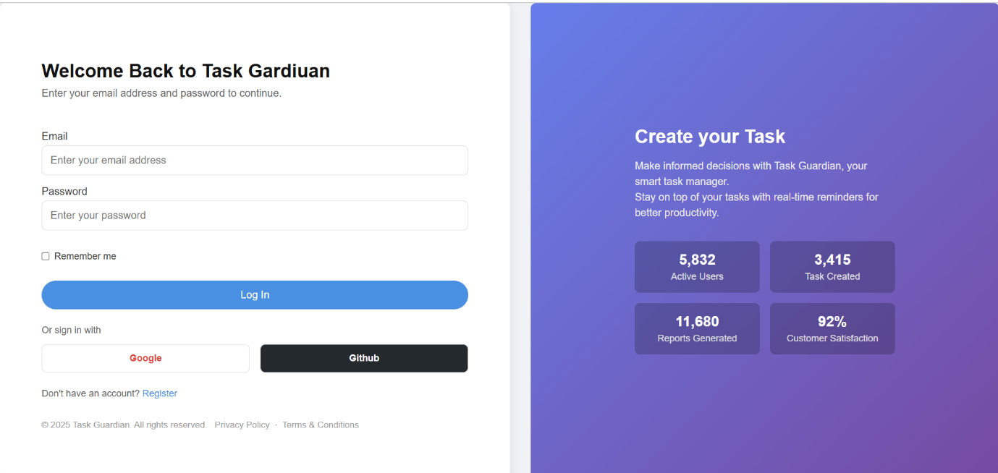**User Sign in Page**
     5. 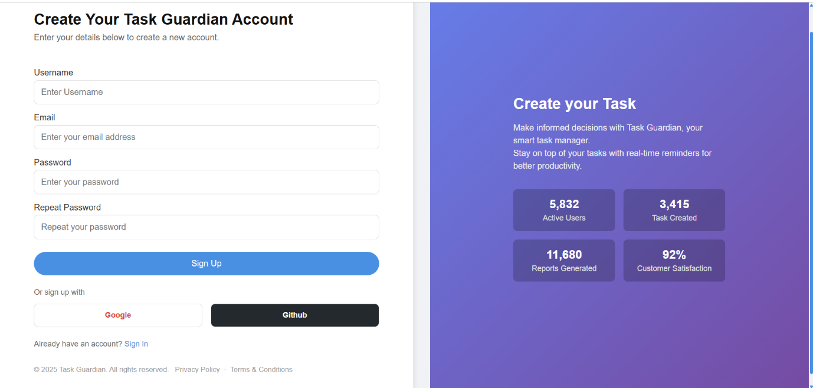**User Sign Up Page**
     6. 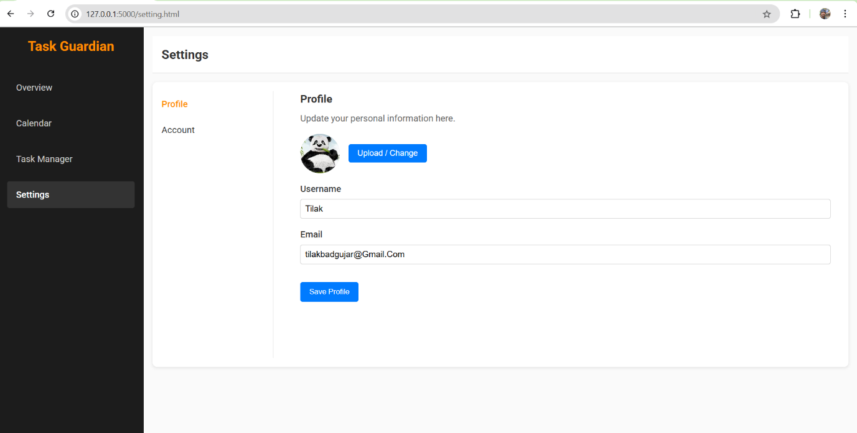**Current User Profile**
     7. **Edit Current User Credential**

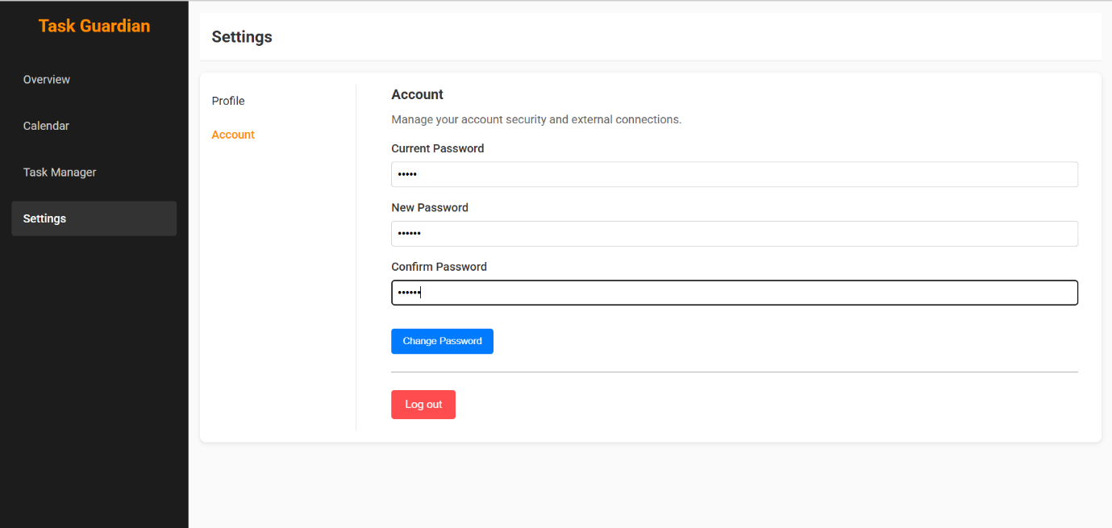

* + 1. 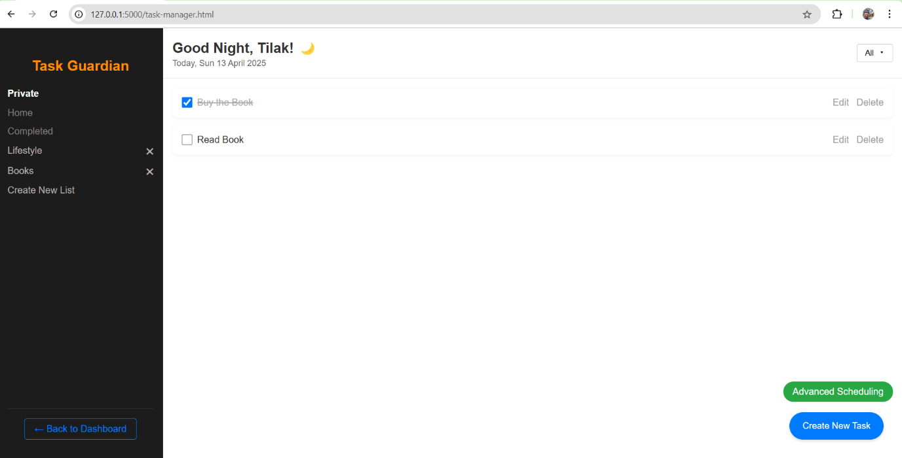**Task Manager Page**
    2. **Create New Task**

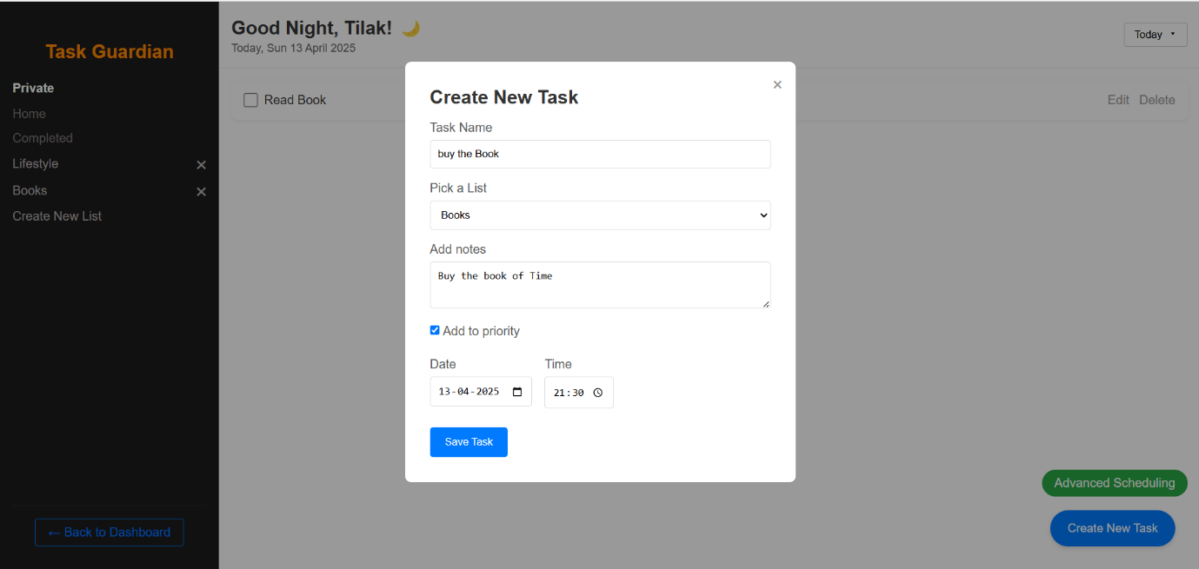

* + 1. **Create New List**

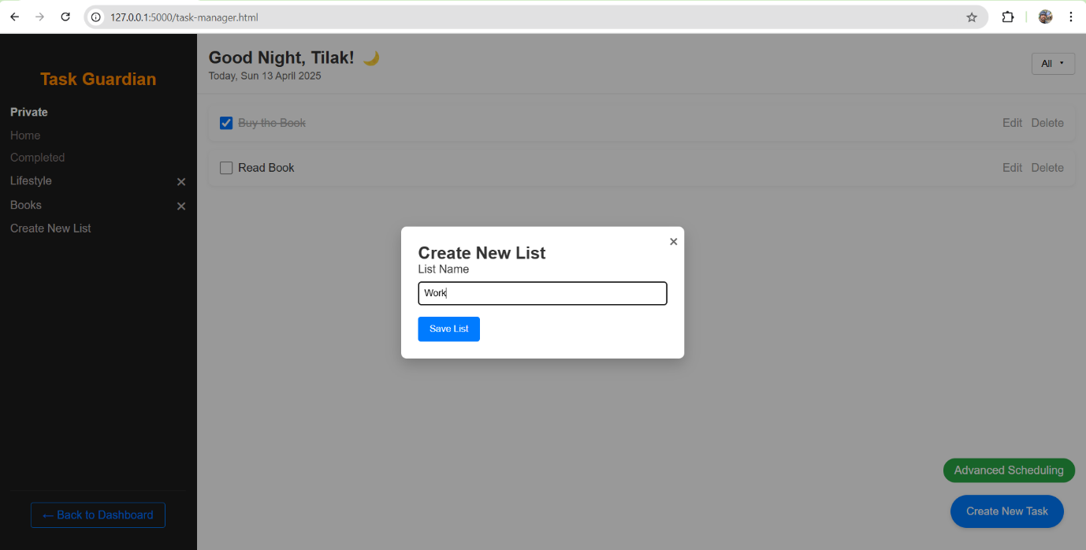

**CHAPTER 5**

**CONCLUSION**

**5.1 Conclusion**

The "Task Guardian" system offers an intelligent, user-centric solution to task management by leveraging modern technologies such as cognitive support, smart scheduling, and full-stack web development. The system provides a reliable, automated platform for organizing tasks, setting reminders, and improving user productivity, thereby eliminating the inefficiencies of traditional to-do lists and manual planners.

By integrating features such as intelligent task prioritization, real-time notifications, and a responsive web interface developed using HTML, CSS, and JavaScript, the system ensures usability, scalability, and performance. The backend, powered by Python and Flask, communicates seamlessly with the frontend, while PostgreSQL handles structured and secure data storage, ensuring consistent and reliable access to user task records.

The use of modern backend frameworks, secure authentication systems (OAuth and traditional login), and cognitive algorithms demonstrates a practical implementation of software engineering best practices. Moreover, the modular and extensible architecture of Task Guardian facilitates easy maintenance and enables future expansion, such as calendar integrations and productivity analytics.

In conclusion, Task Guardian is a successful demonstration of how intelligent task management systems can be built to enhance daily productivity through the integration of cognitive support, smart notifications, and modern web technologies.

**5.2 Limitations**

The While **Task Guardian** is an effective smart task management system, it also presents certain limitations that may impact its performance, usability, and adaptability:

* **Personalization Depth:** Although cognitive prioritization exists, deeper personalization such as behavior-based task suggestions or adaptive learning from user history can be improved.
* **Reminder Accuracy:** In some cases, notification timing might not align perfectly with user routines, leading to potential reminder fatigue or missed alerts.
* **Cross-Device Syncing:** The current version may have limited functionality for real-time syncing across multiple devices or platforms without dedicated mobile or cloud sync features.
* **User Interface Complexity:** Users unfamiliar with digital tools may experience a learning curve when managing task details or settings.
* **Scalability Constraints:**  While PostgreSQL ensures robust local data handling, large-scale or enterprise-level deployments may require performance tuning and cloud-based load handling mechanisms.
* **Limited Offline Support:** Functionality is currently dependent on online connectivity, limiting usability during network outages.

**5.3 Future Enhancements**

To further improve Task Guardian, several enhancements are proposed to expand its functionality, accessibility, and intelligence:

* **Cloud Integration**: Introduce cloud-based databases and hosting (e.g., AWS, Azure, Google Cloud) to support multi-user access, cross-platform data syncing, and large-scale deployment.
* **Advanced Cognitive Features:** Integrate machine learning models for dynamic task suggestions, behavioral analysis, and personalized productivity insights.
* **Mobile Application**: Develop a native or cross-platform mobile app to allow on-the-go task management, push notifications, and voice input.
* **Multilingual and Accessibility Support:** Add support for regional languages and voice-assisted task creation to improve accessibility for non-English speakers and users with disabilities.
* **Calendar and Email Integration:** Sync tasks with Google Calendar or Outlook and send email-based reminders for upcoming deadlines.
* **Collaboration Features:** Enable task sharing, group planning, and team productivity dashboards for collaborative environments.
* **Offline Mode:** Allow local task creation and syncing once online access is restored for uninterrupted productivity.
* **Analytics Dashboard:** Provide insights into task completion trends, time spent on tasks, and performance metrics to enhance productivity tracking.

**BIBLIOGRAPHY**

**Web Source: -**

* <https://www.google.com/>: Used for extensive research, resolving bugs, and finding examples or documentation to integrate the frontend, backend, authentication, and notification systems effectively for the smart task reminder functionality
* <https://www.wikipedia.org/>: Provided theoretical insights on task management systems, cognitive computing, Flask framework, and general concepts related to user interaction design and productivity tools.
* <https://stackoverflow.com/questions>: A vital resource for debugging issues in JavaScript, Python, and resolving integration problems between Flask, database logic, and frontend behavior. It also helped optimize code for reminders, token-based recovery, and session handling.
* <https://pypi.org/>: Used to explore and install necessary Python packages like Flask, Flask-Mail, Flask-OAuth, PyJWT, and pymongo that were critical for backend operations, authentication mechanisms, and scheduled task management.
* <https://www.python.org/> : Served as the official reference for understanding Python syntax, libraries, and best practices for implementing backend logic, including secure APIs, database communication, and user session handling.